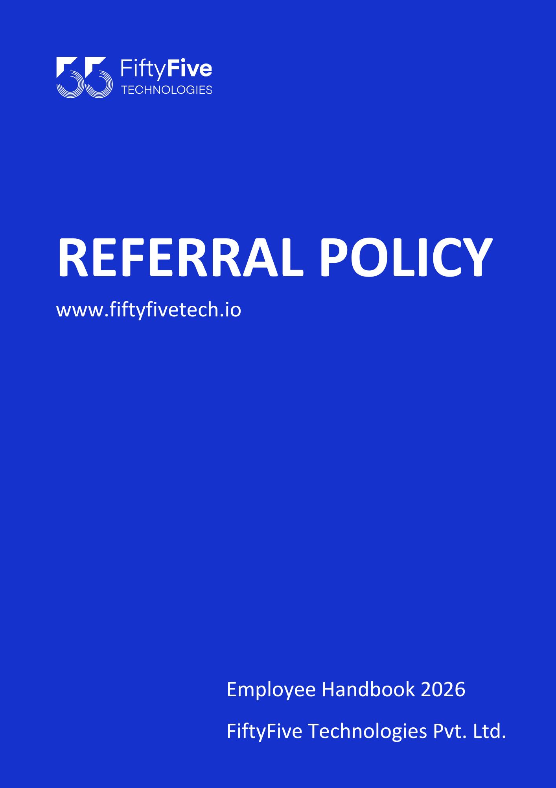

REFERRAL POLICY

Document Release Notice

This FiftyFive Technologies Policy on referral policy is released for use in FiftyFive Technologies Pvt Limited with effect from 01 January 2026.

This document is subject to FiftyFive Technologies Pvt Limited Procedure and subject to change at any time as per the company policy.

Approved By: Jyothi Sharma (CEO-FiftyFive Technologies Pvt. Limited)
Approved By: Sanchi Saxena (Head HR-FiftyFive Technologies Pvt Limited)

Employee Referral Policy

Introduction
This Employee Referral Policy outlines the framework for encouraging employees of FiftyFive Technologies to recommend suitable candidates for open positions within the organization. The policy defines the process, eligibility, and reward structure for employee referrals, aiming to support efficient talent acquisition while maintaining fairness, transparency, and cost-effective hiring practices.

Objective
To define the procedures and guidelines for rewarding employees of FiftyFive Technologies who contribute to identifying and attracting suitable and competent talent, in order to meet organizational resource requirements in a timely and cost-effective manner.

Eligibility
  - All current employees of FiftyFive Technologies including trainees on rolls of the Company are covered under this policy.
  - The referral Policy hence is not applicable for the HR department as it is to be considered that they are a part of hiring procedures.
  - The referral policy is not applicable for the freelancers/ part timers in the company.

Procedure
  - Employees may refer individuals who fit the specifications given in job descriptions for vacant positions which Human Resources posts from time to time.
Note: If the referred candidate’s resume is already available in the Company’s database or has been referred earlier through another source, the referral will be considered on a first-come, first-served basis. Duplicate referrals will not be eligible for referral incentives.
  - The employee’s role will be limited to the submission of the resume of the candidate. After this the regular process of short listing and interviews will be applied to the referrals also.
  - The employee making the referral will not in any way be involved with the interview or salary fixation of the candidate.
  - Selection of referred candidates by any employee would be made only after going through the selection process, as per recruitment policy / procedures.
  - There should be no specific canvassing in case of a referred candidate by both the employee who referred him and the HR.
  - If the preferred candidate is hired, the referrer is eligible to claim a referral fee as per the parameters defined below:

Parameters
The following is the referral incentive applicable under this policy:
Grade | Experience Bracket | Referral Incentive in INR
Associate Technical Lead/Senior Manager/Senior Software Developers/Senior Executives/ Manager | 5 Years and above | 25,000
Software Developers/Software Engineers/Executives | 1 Years-4 Years | 15,000
Trainee/Intern | - | NIL

The Referral incentive is paid along with the salary after the successful completion of the referred candidate’s 3 months with the Company and hence referral bonus will be credited to the payroll of the falling month.

Terms & Conditions:
  - The incentive will be credited to the employee only if the new recruit completes 3 months of employment with the organization.
  - Incentive amounts and eligibility factors are subject to change based on the business and economic needs of FiftyFive Technologies.
  - Incentive will be applicable only on the first come first served.
  - COMPANY, will not enter into any debate with an employee who has unsuccessfully referred a personal contact. In the event of any dispute, the decision of the Head of Human Resources shall be final.
  - All recommendations made by the company’s employees must come from their personal contacts / connections and not through any recruitment agency.
  - Referral bonus is not applicable for the employees working in the human resources department/ the freelancers/part-timers in the company or employees on a contractual basis.

Right to Amend Policies
This Employee Handbook is intended to provide general guidance on Company policies and practices. FiftyFive Technologies reserves the right to amend, modify, suspend, or withdraw any policy, procedure, or benefit described in this handbook at any time, with or without notice, based on business, operational, or legal requirements.


